**Project Name:**

**Hotel Management System**

**Name : Mariam Ahmed Khamis**

**Description:***Hotel Management System is a system that allows the hotel manager to handle all hotel activities online ,The system allows the manager to post available rooms in the system. Customers can view and book room online. The system is hence useful for both customers and managers to portable manage the hotel activities.*

**Function Requirement:**

**Customers:**

**-input**

**1)customers’ information.**

**-output**

**1)Bill information.**

**2)Accommodation information.**

**- processing**

**1) Calculate the bill information based on duration of Accommodation, number of booked rooms, meals and discount.**

**2) Check available services and rooms to get Accommodation information.**

**Admin:**

**- output**

**1) Accommodation information.**

**2) customers’ information.**

**- Processing**

**1) make reports of available and booked rooms.**

**2) Calculation the average number of customers per month and most popular countries.**

Context Diagram

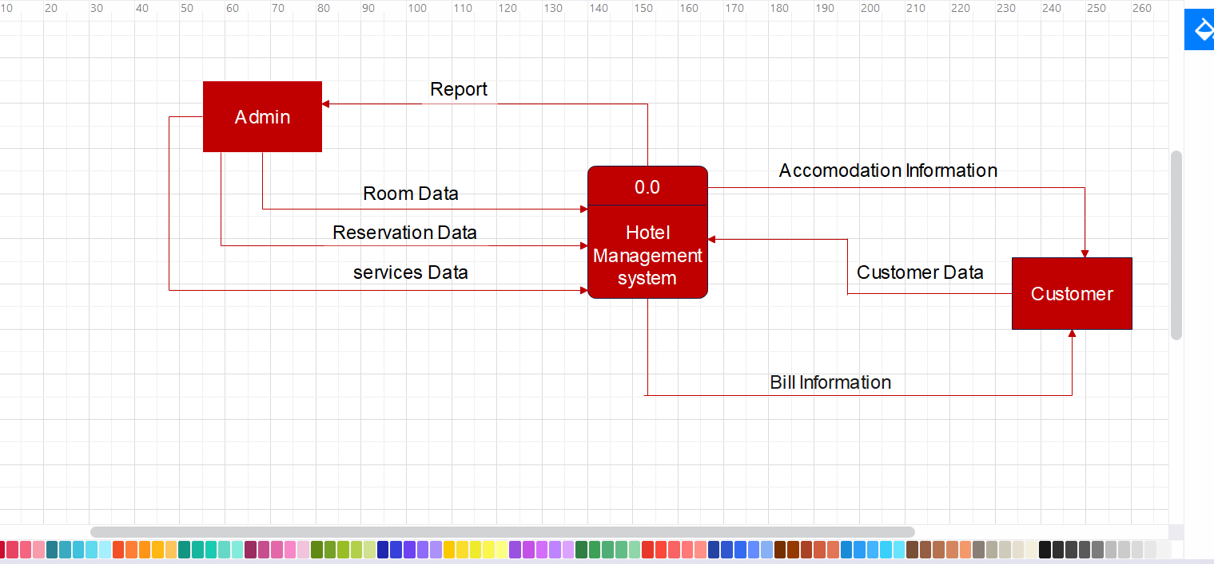

**DFD:level 1**

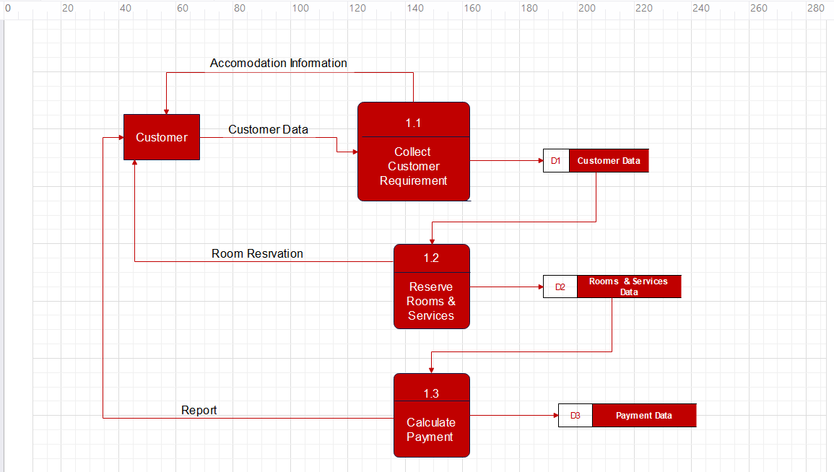

**Use case diagram**

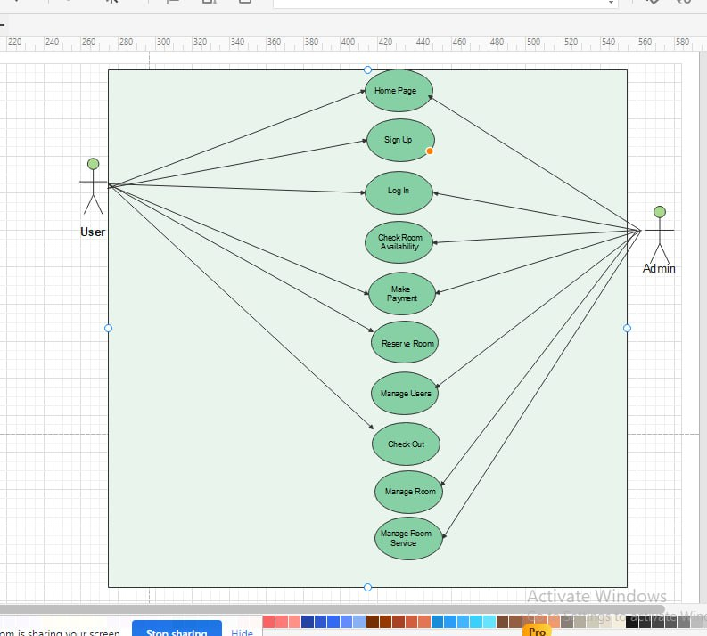

Table Use Case

1. Sign Up

|  |  |  |
| --- | --- | --- |
| **Use Case Name :** | Sign Up | |
| **Actor (s)** | User | |
| **Description :** | his use case describes the process of a user creating a new account on the website. | |
| **Typical Course of Events :** | **Actor Action** | **System Response** |
| Step 1: The user clicks on the "Sign Up" button on the website's homepage.  Step 6: The user clicks on the "Submit" button to complete the registration process.  Step 8: The user logs in to their new account using the email address and password they provided during registration. | Step 2: The website displays the registration form for the user to fill out.  Step 3: The user enters their personal information such as name, email address, and password.  Step 4: The website validates the user's email address to ensure it is not already registered.  Step 5: The website checks the password strength to ensure it meets the minimum requirements.  Step 7: The website creates a new user account and stores the user's information in the database. |

|  |  |
| --- | --- |
| **Alternate Courses.** | Step 4: If the email address is already registered, the website displays an error message to the user and prompts them to use a different email address.  Step 5: If the password does not meet the minimum requirements, the website displays an error message to the user and prompts them to choose a stronger password. |
| **Precondition:** | None. |
| **Post condition:** | The user has successfully created a new account on the website and can now log in using their email address and password. |
| **Assumption:** | None |

1. Manage User

|  |  |  |
| --- | --- | --- |
| **Use Case Name :** | Manage User | |
| **Actor (s)** | User | |
| **Description :** | This use case describes the process of a user managing their account information on the website. | |
| **Typical Course of Events :** | **Actor Action** | **System Response** |
| Step 1: The user logs in to their account using their email address and password.  Step 8: The website updates the user's account information in the database. | Step 2: The website displays the user's account dashboard.  Step 3: The user selects the "Manage Account" option.  Step 4: The website displays the user's account information, such as name, email address, and password.  Step 5: The user updates their account information as necessary.  Step 6: The website validates the updated information to ensure it is accurate and complete.  Step 7: The user clicks on the "Save" button to submit the updated information. |

|  |  |
| --- | --- |
| **Alternate Courses.** | Step 5: If the user wants to change their email address, the website checks to ensure the new email address is not already registered and is in a valid format.  Step 6: If the user wants to change their password, the website checks the password strength to ensure it meets the minimum requirements. |
| **Precondition:** | The user is logged in to their account. |
| **Post condition:** | The user's account information has been updated in the database. |
| **Assumption:** | None. |

1. Home page

|  |  |  |
| --- | --- | --- |
| **Use Case Name :** | Home page | |
| **Actor (s)** | User & Admin | |
| **Description :** | This use case describes the process of a user managing their account information on the website. | |
| **Typical Course of Events :** | **Actor Action** | **System Response** |
| Step 1: The user logs in to their account using their email address and password.  Step 7:The website displays a success message to the user, indicating that their account information has been updated. | Step 2: The website displays the user's account dashboard.  Step 3: The user selects the "Manage Account" option.  Step 4: The website displays the user's account information, such as name, email address, and password.  Step 5: The user updates their account information as necessary.  Step 6: The website validates the updated information to ensure it is accurate and complete. |

|  |  |
| --- | --- |
| **Alternate Courses.** | Step 5: If the user wants to change their email address, the website checks to ensure the new email address is not already registered and is in a valid format.  Step 6: If the user wants to change their password, the website checks the password strength to ensure it meets the minimum requirements. |
| **Precondition:** | The user is logged in to their account. |
| **Post condition:** | The user's account information has been updated in the database. |
| **Assumption:** | None |

**4- Login**

|  |  |  |
| --- | --- | --- |
| **Use Case Name :** | Login the system | |
| **Actor (s)** | Customer / Admin | |
| **Description :** | This use case describes the process of the customer logging in and logging out from the system. | |
| **Typical Course of Events :** | Actor Action | System Response |
| Step 1: This use case is initiated when the customer accesses the system login page. | Step 2: The customer enters their login credentials, including username and password.  Step 3: The system validates the login credentials and grants the customer access to their account.  Step 4: The customer performs their desired actions within the system.  Step 5: The system logs the customer out of their account and returns them to the login page. |

|  |  |
| --- | --- |
| **Alternate Courses.** | Step 3: If the customer enters invalid login credentials, the system notifies the customer and prompts them to try again or reset their password.  Step 4: If the customer encounters any errors or issues while using the system, they may need to contact customer support for assistance. |
| **Precondition:** | The customer has an account with the system and has access to the login page. |
| **Post condition:** | The customer has successfully logged in and out of the system. |
| **Assumption:** | The customer has a valid username and password for their account. |

**5-Reserve Room**

|  |  |  |
| --- | --- | --- |
| **Use Case Name :** | Reserve Room | |
| **Actor (s)** | Customer | |
| **Description :** | This use case describes the process of the customer booking a room in a hotel or other lodging establishment. | |
| **Typical Course of Events :** | **Actor Action** | **System Response** |
| Step 1: This use case is initiated when the customer accesses the hotel booking system.  Step 7: This use case concludes when the customer has successfully booked a room. | Step 2: The customer enters the desired check-in and check-out dates and selects the number of guests and rooms.  Step 3: The system displays a list of available rooms that match the customer's search criteria.  Step 4: The customer selects a room and enters their personal information, including name, address, and payment details.  Step 5: The system validates the customer's information and confirms the booking.  Step 6: The system generates a booking confirmation and sends it to the customer via email or other notification method. |

|  |  |
| --- | --- |
| **Alternate Courses.** | Step 3: If no rooms are available for the selected dates, the system notifies the customer and prompts them to select different dates or search for other lodging options.  Step 4: If the customer enters invalid information, the system notifies them and prompts them to correct the information.  Step 5: If the customer's payment information is invalid or cannot be validated, the system prompts them to enter valid payment information. |
| **Precondition:** | The customer has access to the hotel booking system. |
| **Post condition:** | The customer has successfully booked a room in the hotel or other lodging establishment.. |
| **Assumption:** | The hotel has available rooms for the selected dates and the customer has valid payment information. |

**6-Manage Payment**

|  |  |  |
| --- | --- | --- |
| **Use Case Name :** | Manage Payment | |
| **Actor (s)** | Admin & Customer | |
| **Description :** | This use case describes the process of the manager managing payments within the system, including recording payments, verifying payment information, and refunding payments. | |
| **Typical Course of Events :** | **Actor Action** | **System Response** |
| Step 1:This use case is initiated when the manager accesses the payment management section of the system.  Step 7: The manager selects the payment they wish to verify.  Step 9: This use case concludes when the manager has completed managing payments in the system. | Step 2: The manager selects the option to record a payment.  Step 3: The system prompts the manager to enter the payment information, including customer name, payment amount, and payment method.  Step 4: The manager enters the payment information and submits the form.  Step 5: The system validates the payment information and records the payment in the system.  Step 6: The manager selects the option to verify payment information.  Step 8: The system prompts the manager to enter the refund information, including the refund amount and reason. |

**7-Manage Rooms**

|  |  |  |
| --- | --- | --- |
| Use Case Name : | Manage Rooms | |
| Actor (s) | Admin | |
| Description : | This use case describes the process of the admin managing the hotel with in the system, including adding new rooms, modifying existing room information, and deleting rooms. | |
| Typical Course of Events Events: | Actor Action | System Response |
| Step 1:this use case is initiated when the admin accesses the hotel management section of the system.  Step 5: The system displays the room's information and allows the admin to make changes.  Step8 : This use case concludes when the admin has completed managing the hotel in the system. | Step 2: The Admin selects the option to add a new room.  Step 3: The system prompts the admin to enter the new room's information, including room number, type, and price.  Step 4: The Admin enters the new room's information and submits the form.  Step 6: The system displays a list of existing rooms for the admin to choose from.  Step 7: The admin confirms the deletion, and the system removes the room from the system. |

|  |  |
| --- | --- |
| **Alternate Courses.** | Step 3: If the new room's information is invalid, the system notifies the admin and prompts them to correct the information.  Step 5: If the admin attempts to modify a room's information in an invalid way, the system notifies the admin and prompts them to correct the information.  Step 6: If the admin attempts to delete a room that is currently occupied or has reservations, the system notifies the admin and prompts them to resolve any outstanding issues before deleting the room. |
| **Precondition:** | The manager has access to the hotel management section of the system. |
| **Post condition:** | The room database has been updated to reflect any changes made by the manager. |
| **Assumption:** | The manager has the necessary permissions to manage the hotel in the system. |

**8-Manage Room Services**

|  |  |  |
| --- | --- | --- |
| **Use Case Name :** | Manage Room Services | |
| **Actor (s)** | Admin | |
| **Description :** | This use case describes the process of the manager managing services within the system, including adding new services, modifying existing service information, and deleting services. | |
| **Typical Course of Events :** | Actor Action | System Response |
| Step 1 : This use case is initiated when the manager accesses the service management section of the system.  Step 8 : The system displays a list of existing services for the manager to choose from. | Step 2 : The manager selects the option to add a new service.  Step 3 : The system prompts the manager to enter the new service's information, including name, description, and price.  Step 4 : The manager enters the new service's information and submits the form.  Step 5 : The system validates the new service's information and adds the service to the system.  Step 6 : The manager selects the option to modify an existing service's information.  Step 7: The system displays the service's information and allows the manager to make changes. |

|  |  |
| --- | --- |
| **Alternate Courses.** | Step 3: If the new service's information is invalid, the system notifies the manager and prompts them to correct the information.  Step 7: If the manager attempts to modify a service's information in an invalid way, the system notifies the manager and prompts them to correct the information.  Step 8 : If the manager attempts to delete a service that is currently in use or has reservations, the system notifies the manager and prompts them to resolve any outstanding issues before deleting the service. |
| **Precondition:** | The manager has access to the service management section of the system. |
| **Post condition:** | The service database has been updated to reflect any changes made by the manager. |
| **Assumption:** | The manager has the necessary permissions to manage services in the system. |

**9 – Check Room Availability**

|  |  |  |  |  |  |
| --- | --- | --- | --- | --- | --- |
| **Use Case Name :** | | Check Room Availability | | | |
| **Actor (s)** | | Customer | | | |
| **Description :** | | This use case describes the process of a customer checking the availability of rooms in a hotel. | | | |
| **Typical Course of Events :** | | **Actor Action** | | **System Response** | |
| Step 1: This use case is initiated when a customer wants to check room availability.  Step 6: The customer confirms the booking and provides personal details such as name, address, and payment information.  Step 7: The system records the booking details and processes the payment.  Step 8: The system generates a booking confirmation and sends it to the customer via email or text message. | | Step 2: The system displays the room availability calendar for the desired dates.  Step 3: The customer selects the desired room type and number of rooms.  Step 4: The system checks the availability of the selected room type and number of rooms for the desired dates.  Step 5: If the selected room type and number of rooms are available, the system displays the total cost of the stay. | |
| **Alternate Courses.** | | Step 4: If the selected room type and number of rooms are not available, the system displays alternative room types or dates that are available.  Step 5: If the customer decides not to confirm the booking, the system cancels the booking process. | |
| **Precondition:** | | The hotel has available rooms for the desired dates. | |
| **Post condition:** | | The customer has made a booking and received a confirmation. | |
| **Assumption:** | | The customer has a valid payment method. | |

**10-Check out**

|  |  |  |
| --- | --- | --- |
| **Use Case Name :** | Check out | |
| **Actor (s)** | Customer | |
| **Description :** | This use case describes the process of a customer checking out of a hotel. | |
| **Typical Course of Events :** | **Actor Action** | **System Response** |
| Step 1: This use case is initiated when a customer wants to check out of the hotel.  Step 4: The customer provides payment information and authorizes the payment.  Step 7: The system finalizes the transaction and updates the room status. | Step 2: The customer provides their room number and any additional charges they have incurred during their stay.  Step 3: The system calculates the total amount due and displays it to the customer.  Step 5: The system processes the payment and generates a receipt.  Step 6: The customer confirms the accuracy of the receipt.  . |

|  |  |
| --- | --- |
| **Alternate Courses.** | Step 2: If the customer has any complaints or issues with their stay, the system alerts the hotel staff to address the issue.  Step 3: If there are any discrepancies in the charges, the customer can dispute them and the system will adjust the total amount due accordingly. |
| **Precondition:** | The customer has stayed in a hotel room and has additional charges to pay. |
| **Post condition:** | The customer has checked out of the hotel and received a receipt. |
| **Assumption:** | The customer has a valid payment method. |

Activity Diagram

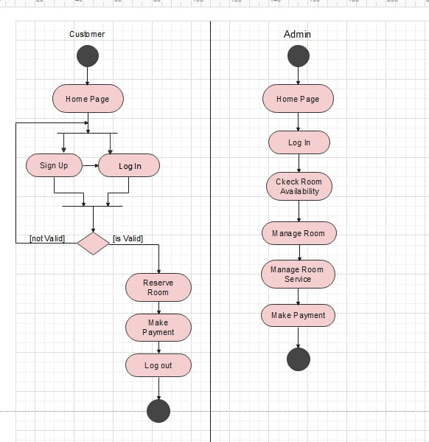

System Sequence Diagram

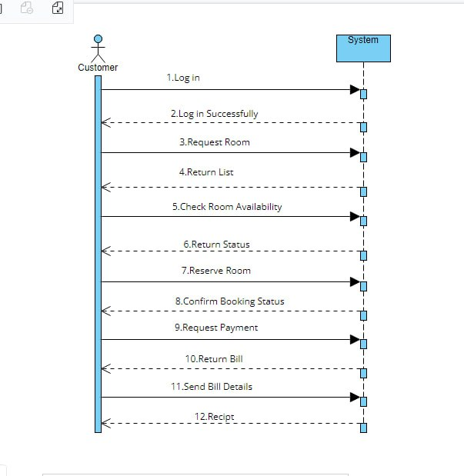

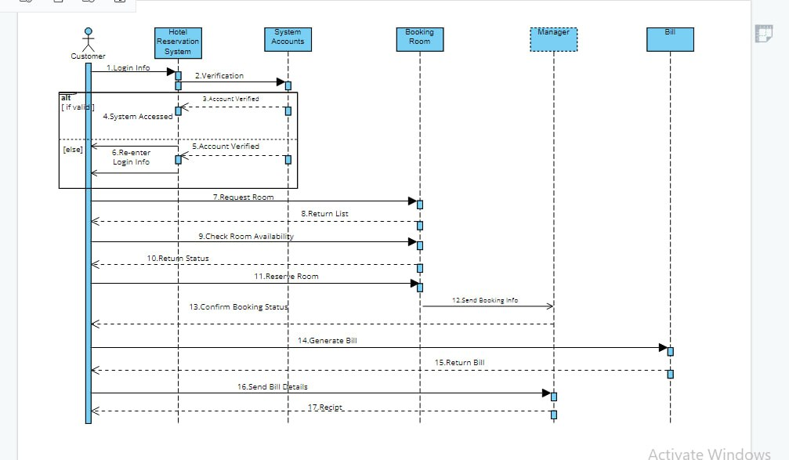

Sequence diagram for use case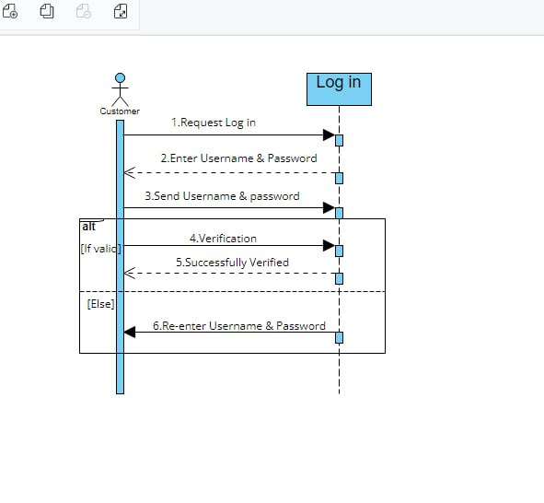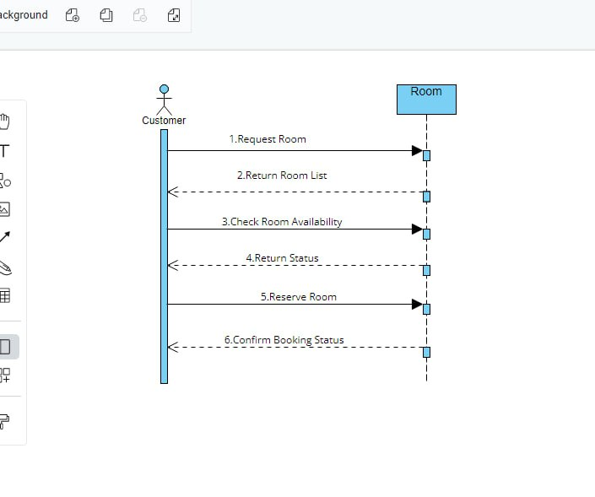

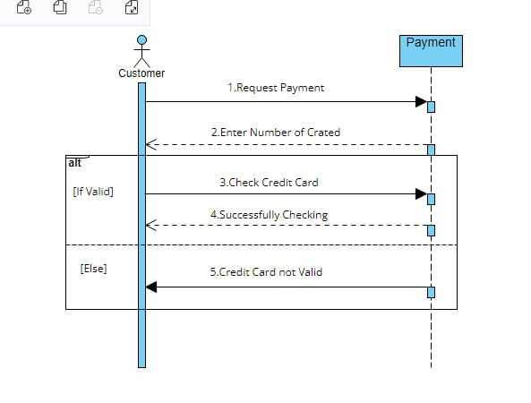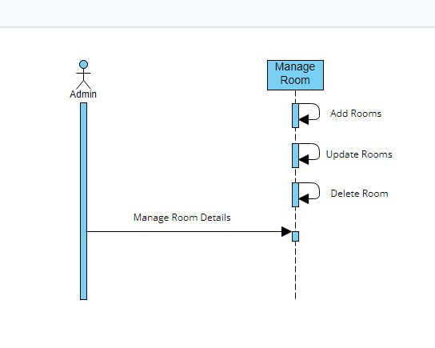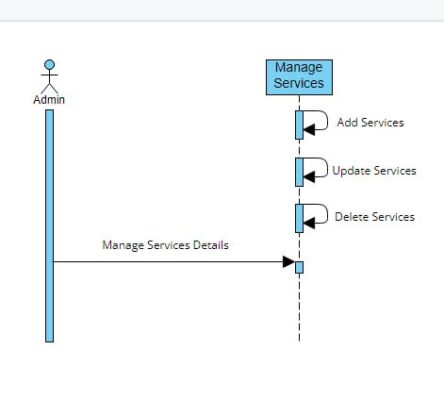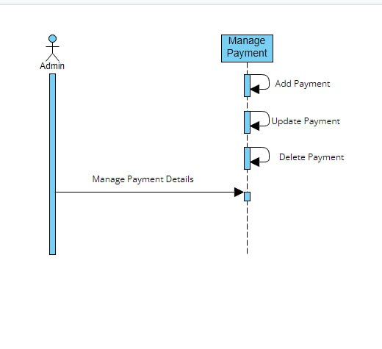

Class Diagram

